**Lab 19: Android External Storage**

# **Introduction**

We can save or read data from the device's external memory, such as an SD card, just like we can from internal storage. The FileInputStream and FileOutputStream classes can be used to read from and write to files kept on external storage, respectively.

**Let’s get Started:**

In this experiment we will develop an Android App to demonstrate the use of Android external storage.

**Step 1: Create a New Project in Android Studio as shown below**

**Step 2: Select Empty Activity as shown below**

**Step 3: Provide a Project Name as shown below**

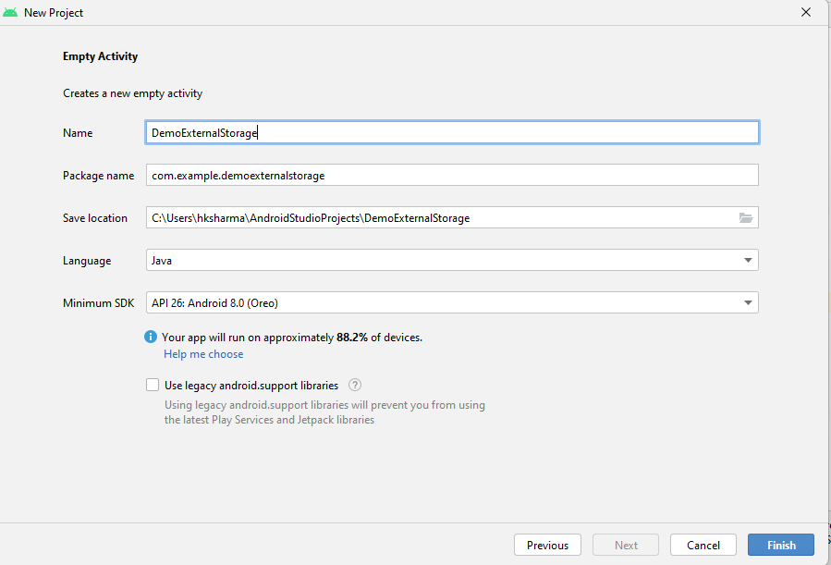

**Step 4: Update MainActivity.java as per the code given below**

**package** com.example.demoexternalstorage2;  
  
**import** android.os.Bundle;  
**import** android.view.View;  
**import** android.widget.Button;  
**import** android.widget.EditText;  
**import** android.widget.Toast;  
**import** androidx.appcompat.app.AppCompatActivity;  
**import** java.io.BufferedReader;  
**import** java.io.File;  
**import** java.io.FileInputStream;  
**import** java.io.FileNotFoundException;  
**import** java.io.FileOutputStream;  
**import** java.io.IOException;  
**import** java.io.InputStreamReader;  
**import** java.io.OutputStreamWriter;  
  
**public class** MainActivity **extends** AppCompatActivity {  
 EditText **editTextFileName**,**editTextData**;  
 Button **saveButton**,**readButton**;  
 @Override  
 **protected void** onCreate(Bundle savedInstanceState) {  
 **super**.onCreate(savedInstanceState);  
 setContentView(R.layout.***activity_main***);  
  
 **editTextFileName**=findViewById(R.id.***editText1***);  
 **editTextData**=findViewById(R.id.***editText2***);  
 **saveButton**=findViewById(R.id.***button1***);  
 **readButton**=findViewById(R.id.***button2***);  
  
 *//Performing action on save button* **saveButton**.setOnClickListener(**new** View.OnClickListener(){  
  
 @Override  
 **public void** onClick(View arg0) {  
 String filename=**editTextFileName**.getText().toString();  
 String data=**editTextData**.getText().toString();  
  
 FileOutputStream fos;  
 **try** {  
 File myFile = **new** File(**"/sdcard/"**+filename);  
 myFile.createNewFile();  
 FileOutputStream fOut = **new** FileOutputStream(myFile);  
 OutputStreamWriter myOutWriter = **new** OutputStreamWriter(fOut);  
 myOutWriter.append(data);  
 myOutWriter.close();  
 fOut.close();  
 Toast.*makeText*(getApplicationContext(),filename + **"saved"**,Toast.***LENGTH_LONG***).show();  
 } **catch** (FileNotFoundException e) {e.printStackTrace();}  
 **catch** (IOException e) {e.printStackTrace();}  
 }  
 });  
  
 *//Performing action on Read Button* **readButton**.setOnClickListener(**new** View.OnClickListener(){  
 @Override  
 **public void** onClick(View arg0) {  
 String filename=**editTextFileName**.getText().toString();  
 StringBuffer stringBuffer = **new** StringBuffer();  
 String aDataRow = **""**;  
 String aBuffer = **""**;  
 **try** {  
 File myFile = **new** File(**"/sdcard/"**+filename);  
 FileInputStream fIn = **new** FileInputStream(myFile);  
 BufferedReader myReader = **new** BufferedReader(  
 **new** InputStreamReader(fIn));  
 **while** ((aDataRow = myReader.readLine()) != **null**) {  
 aBuffer += aDataRow + **"\n"**;  
 }  
 myReader.close();  
 } **catch** (IOException e) {  
 e.printStackTrace();  
 }  
 Toast.*makeText*(getApplicationContext(),aBuffer,Toast.***LENGTH_LONG***).show();  
 }  
 });  
 }  
}

**Step 5: Update activity_main.xml as per the code given below**

*<?***xml version="1.0" encoding="utf-8"***?>*<**LinearLayout xmlns:android="http://schemas.android.com/apk/res/android"  
 xmlns:tools="http://schemas.android.com/tools"  
 android:layout_width="match_parent"  
 android:layout_height="match_parent"  
 android:orientation="vertical"  
 android:gravity="center"  
 tools:context=".MainActivity"** >  
  
 <**TextView  
 android:layout_width="wrap_content"  
 android:layout_height="wrap_content"  
 android:text="External Storage Example"  
 android:layout_centerHorizontal="true"  
 android:textSize="30dp"** />  
  
 <**EditText  
 android:id="@+id/editText1"  
 android:layout_width="wrap_content"  
 android:layout_height="wrap_content"  
 android:hint="Enter a File Name "  
 android:layout_marginTop="24dp"  
 android:ems="10"** >  
 <**requestFocus** />  
 </**EditText**>  
  
 <**EditText  
 android:id="@+id/editText2"  
 android:layout_width="wrap_content"  
 android:layout_height="wrap_content"  
 android:layout_marginTop="24dp"  
 android:hint="Enter Data to Store"  
 android:ems="10"** />  
 <**Button  
 android:id="@+id/button1"  
 android:layout_width="wrap_content"  
 android:layout_height="wrap_content"  
 android:text="Write Data"** />  
 <**Button  
 android:id="@+id/button2"  
 android:layout_width="wrap_content"  
 android:layout_height="wrap_content"  
 android:text="Read Data"** />  
  
</**LinearLayout**>

**Step 6: Update AndroidManifest.xml as per the code given below**

*<?***xml version="1.0" encoding="utf-8"***?>*<**manifest xmlns:android="http://schemas.android.com/apk/res/android"  
 xmlns:tools="http://schemas.android.com/tools"**>  
 <**uses-permission android:name="android.permission.WRITE_EXTERNAL_STORAGE"**/>  
 <**application  
 android:allowBackup="true"  
 android:dataExtractionRules="@xml/data_extraction_rules"  
 android:fullBackupContent="@xml/backup_rules"  
 android:icon="@mipmap/ic_launcher"  
 android:label="@string/app_name"  
 android:roundIcon="@mipmap/ic_launcher_round"  
 android:supportsRtl="true"  
 android:theme="@style/Theme.DemoExternalStorage2"  
 tools:targetApi="31"**>  
 <**activity  
 android:name=".MainActivity"  
 android:exported="true"**>  
 <**intent-filter**>  
 <**action android:name="android.intent.action.MAIN"** />  
  
 <**category android:name="android.intent.category.LAUNCHER"** />  
 </**intent-filter**>  
  
 <**meta-data  
 android:name="android.app.lib_name"  
 android:value=""** />  
 </**activity**>  
 </**application**>  
</**manifest**>

**Step 7: Check Output on Android Emulator and it should look like as given below**

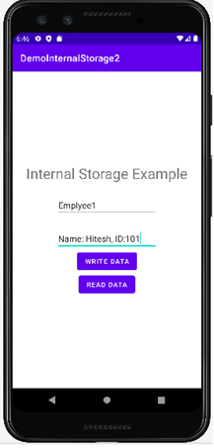

External Storage Example

**Voila!!** We have successfully completed this lab.